CHIMACUM MIDDLE SCHOOL
STUDENT-LED CONFERENCES
Mark your calendar—Wednesday, April 20, 2016

The purpose of this document is to provide you with information about our “student-led conferences” at Chimacum Middle School.

Conference Purposes:
The “student-led conference” is different in purpose from the parent conferences we had in October. Educational research shows that students need to have a greater role in their own education. At this conference, students will present a portfolio directly to their parents detailing their progress in meeting standards and goals for their future. CMS adds this process as one more step in raising the standards and raising the success rate for our students. Other school districts using this conferencing process report parents find these conferences very beneficial.

Students should have been collecting work samples for their portfolios, reviewing their progress for the year and setting goals. Every student will also plan and practice for a presentation to his or her parents/guardians on Wednesday, April 20, 2016 at a time scheduled between the parents and the child’s 2nd period homeroom teacher.

The desired results from this process are as follows:
- Students will accept personal responsibility for their academic performance.
- Students will learn the process of self-evaluation.
- The process will facilitate the development of students’ organizational and oral communication skills and increase their self-confidence.
- More parents will be involved in the education of students.

Scheduling Conferences:
All conferences will be held Wednesday, April 20, 2016. Your child’s 2nd period homeroom teacher will facilitate the conference and schedule your appointment. In the case that a parent/guardian cannot attend, another designated adult should come to the conference. The goal is to have every student lead a conference.

The staff is eager to have you share in our students’ educational growth. We want all of our students to be successful!

Please indicate your choice for conference time to your child’s homeroom teacher by Friday, April 15th at the latest.

“EDUCATION IS POWER”

Student-Led Conference Times
April 20, 2016

Parents, please select a time for you child’s conference. Fill out the online form mentioned here for your child’s 2nd period homeroom teacher who will facilitate the conference. A time will be scheduled and you will be notified of your scheduled time slot by email.

OPTION 1
If you or another parent, guardian, relative, or friend will be attending the conference on April 20th put the following link into your phone or web browser to choose a time slot (each time slot can have up to four appointments before it will no longer be available): goo.gl/TrRJnf

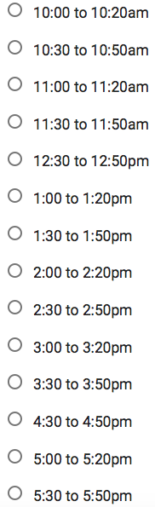

OPTION 2
If you or another parent/guardian cannot attend, but would like your son/daughter to proceed with a community volunteer, please sign below.

_______________________________

OPTION 3
If your child will be attending the WE Day event, please contact Mr. González by email at al_gonzalez@csd49.org to schedule your child’s conference for another day after school.

