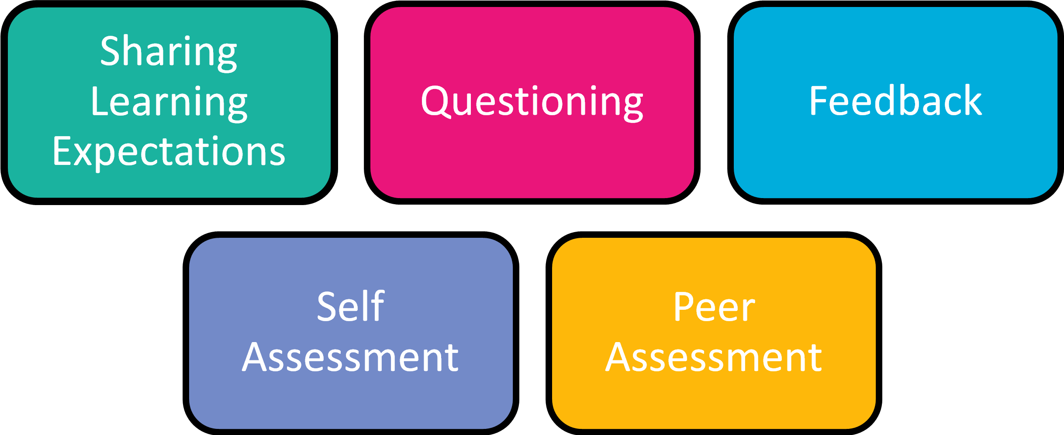
Assessment for Learning
Five Key Strategies

